**Table 1.** Key terms and definitions relating to human-coyote interactions in Edmonton, Alberta.

|  |  |
| --- | --- |
| **Term** | **Definition** |
| Conflict | Occurs when coyotes present a threat, real or perceived, to the well-being of people, pets or property. |
| Coexistence | Co-occurrence of humans and coyotes that minimizes conflict. |
| Sighting | Observation of a coyote at a distance with no interaction. |
| Encounter | Interaction between a coyote and a person/pet at close range. Depending on coyote boldness and human concern, encounters may be reported as positive, if conflict does not occur, or negative, if conflict occurs. |
| Coyote boldness | Ordinal scale indicator of the level of human-coyote conflict determined from the reported coyote behaviour/response towards people or pets. |
| Human concern | Ordinal scale indicator of the level of human-coyote conflict determined from the human perception of coyotes expressed in the report. |

**Table 2.** Distribution of coyote reports across coyote boldness ordinal scale values.

|  |  |  |  |
| --- | --- | --- | --- |
| **Coyote Boldness (ordinal scale value)** | **Description and form classification as coyote behaviour** | **Number of Reports** | **Percentage of Total Reports** |
| **Avoidance (1)** | Ran away | 645 | 7.2% |
|  | Walked away | 348 | 3.8% |
| **Indifferent (2)** | Did not appear to notice or care about people | 1105 | 12.2% |
|  | Watched the person | 381 | 4.2% |
|  | Vocalized at the person | 46 | 0.5% |
| **Bold (3)** | Followed or stalked pets or people | 464 | 5.1% |
|  | Approached pets or people | 218 | 2.4% |
| **Aggressive (4)** | Chased or charged pets or people | 194 | 2.1% |
|  | Physical contact with pets or people | 139 | 1.5% |
| **Sighting (N/A)** | Reports were submitted as sightings or comments indicated no interaction between people and coyote(s) | 4770 | 52.2% |
| **Unknown (N/A)** | Reports were submitted as encounters, but coyote boldness could not be determined | 824 | 9.0% |

**Table 3.** Distribution of reports across human concern ordinal scale values.

|  |  |  |  |
| --- | --- | --- | --- |
| **Human Concern† (ordinal scale value)** | **Description and form classification as human perception about coyotes** | **Number of Reports** | **Percentage of Total Reports** |
| **Positive (low concern; 1)** | Reports containing words like love, happy, exciting, cool or beautiful | 147 | 1.6% |
| **Neutral (medium concern; 2)** | Reports containing words like surprised or curious about the coyote, or denying negative reaction to the presence of the coyote | 195 | 2.1% |
| **Negative (high concern; 3)** | Reports containing words like scared, nervous, disturbed, concerned, uncomfortable or alarmed | 718 | 7.9% |
| **Unknown (N/A)** | Human perceptions about coyotes could not be determined | 7958 | 87.1% |

† 116 (1.3%) reports where reporters were concerned for the well-being of the coyote were excluded.

**Table 4.** Land cover classes representing different degrees of human development and coyote habitat suitability in Edmonton, Alberta as determined from the City of Edmonton Urban Planning Land and Vegetation Inventory (uPLVI) site types.

|  |  |
| --- | --- |
| **Land Cover Class (uPLVI site types)** | **% Study Area** |
| 1. Natural   (forested, native grass, closed shrub, medial shrub, exposed mineral soil, marsh, treed fen, shrubby fen) | 8.2% |
| 1. Modified Open   (annual crops, tame pasture, rough pasture, agriculture hygric tillage site, non-maintained grass/shrub, recent clearing, farmyard/acreage, treed shelterbelt, transplant treed site, nursery/tree farm) | 16.0% |
| 1. Mowed   (maintained grass site) | 7.7% |
| 1. Residential   (established residential community, residential development site, acreage subdivision) | 42.0% |
| 1. Commercial   (established commercial/industrial, commercial/industrial development, aggregates or fill sites, building and/or parking complex, oil and gas field site, transportation surface) | 23.4% |
| 1. Water   (anthropogenic water, natural water) | 2.7% |

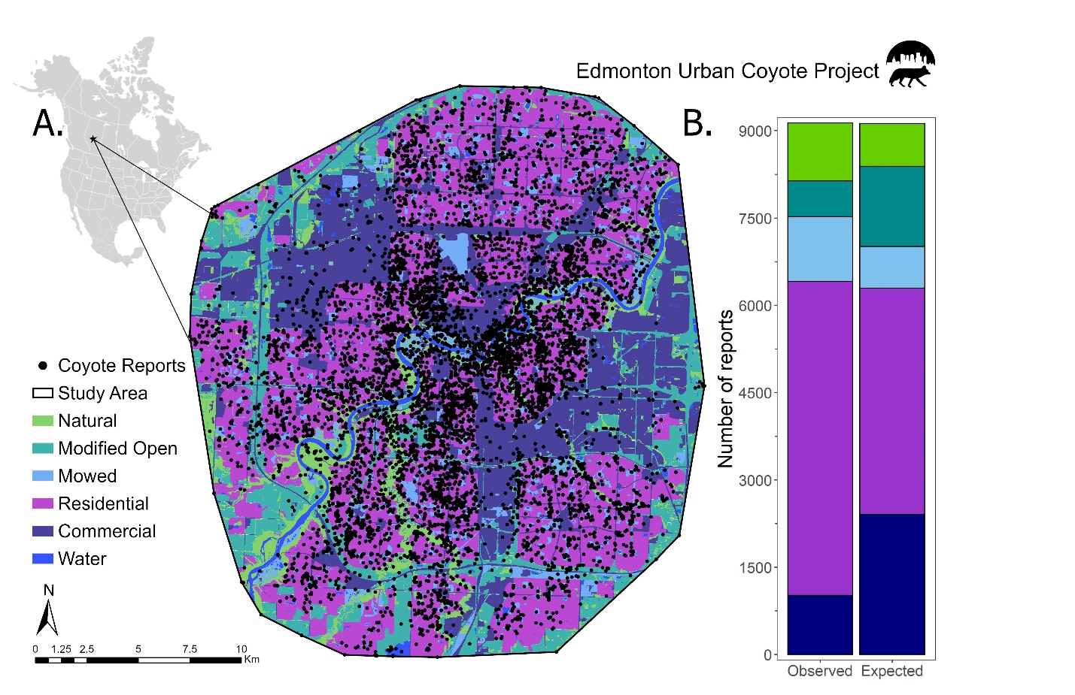

**Figure 1.** Distribution of coyote reports across Edmonton, Canada (A) and across land cover categories (B). Reports were collected from 2011-2021 through the Edmonton Urban Coyote project website and included the location of the coyote sighting or interaction.

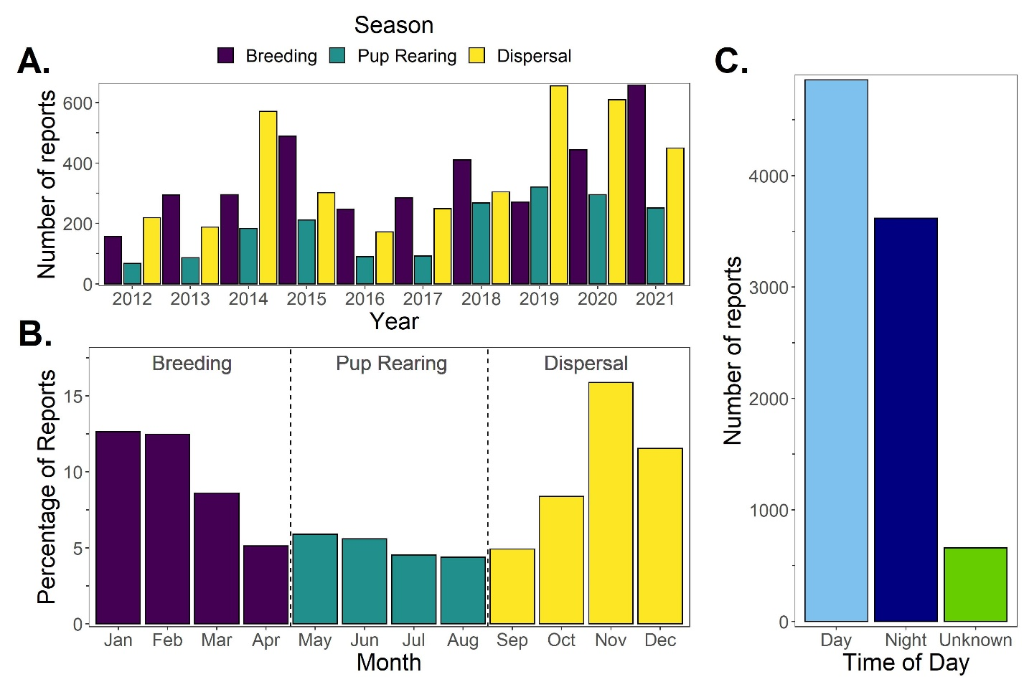

**Figure 2.** Temporal patterns in coyote reporting across years (A), months (B), coyote seasons (A & B) and time of day (C). Reports were collected through the Edmonton Urban Coyote project website and the date and time of report were submitted by the reporter.

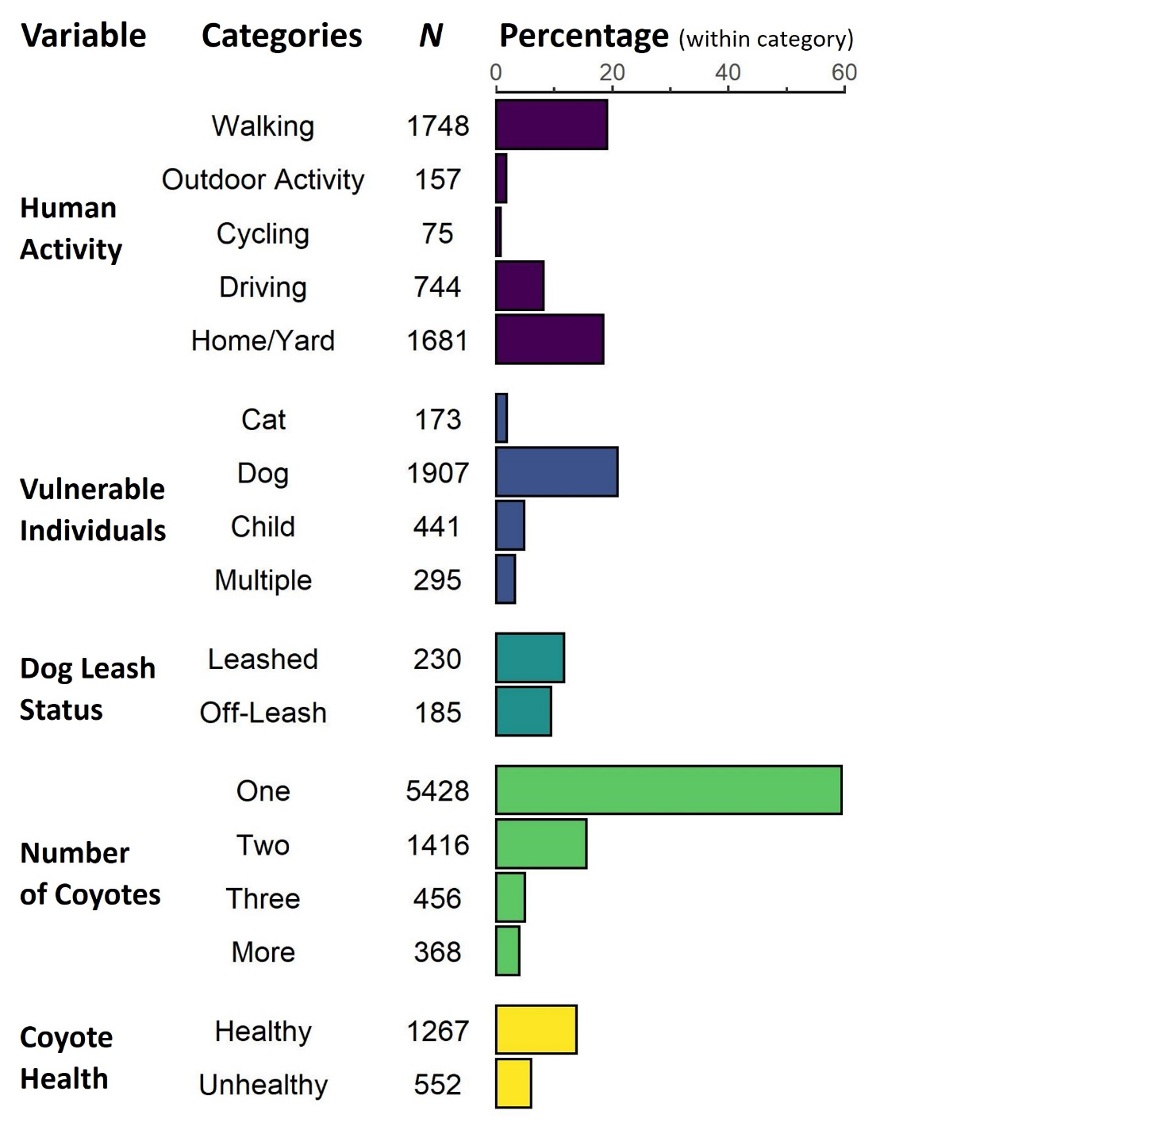

**Figure 3.** Coyote report distribution across contextual variables. Percentages were calculated based on the total number of reports (*N* = 9,134) with the exception of dog leash status, which is based on the number of reports that mentioned dogs (*N* = 1,958). The remaining (unplotted) reports for each category did not provide relevant information about the contextual variable.

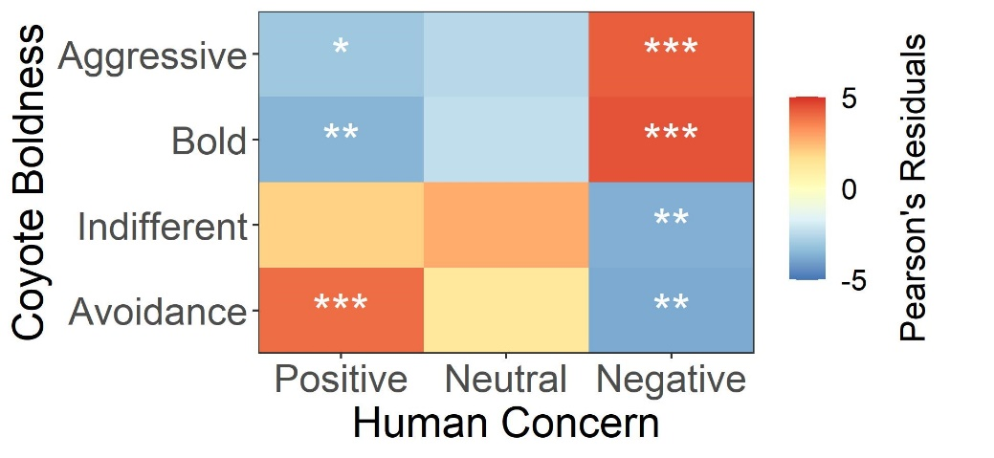

**Figure 4.** Relationship between coyote boldness, determined from reported coyote behaviour, and human concern about coyotes, determined from participant’s perceptions of coyotes. Colors represent Pearson’s residual values calculated post-hoc from a chi square test, with positive values (red) indicating positive relationships and negative values (blue) indicating negative relationships. Significance is indicated by asterisks (* p < 0.05, ** p <0.01, *** p < 0.001).

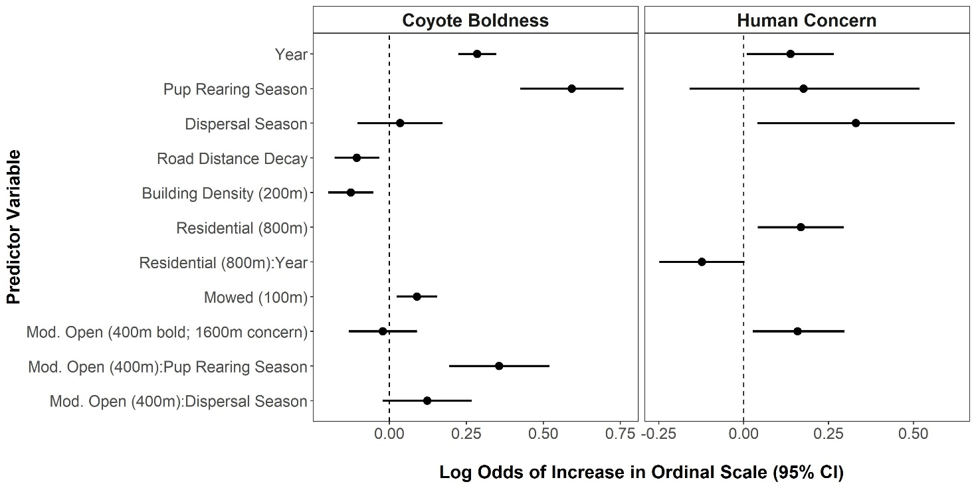

**Figure 5.** Log odds coefficient values and 95% confidence intervals for the explanatory variables retained in the top ordered logistic regression models (lowest AICc) for coyote boldness and human concern of coyotes. The full set of variables included in each global model is available in Table 5 of Appendix 3. Positive values indicate that the variable causes a higher likelihood of conflict-associated coyote behaviour or human concern, while negative values suggest reduced likelihoods.

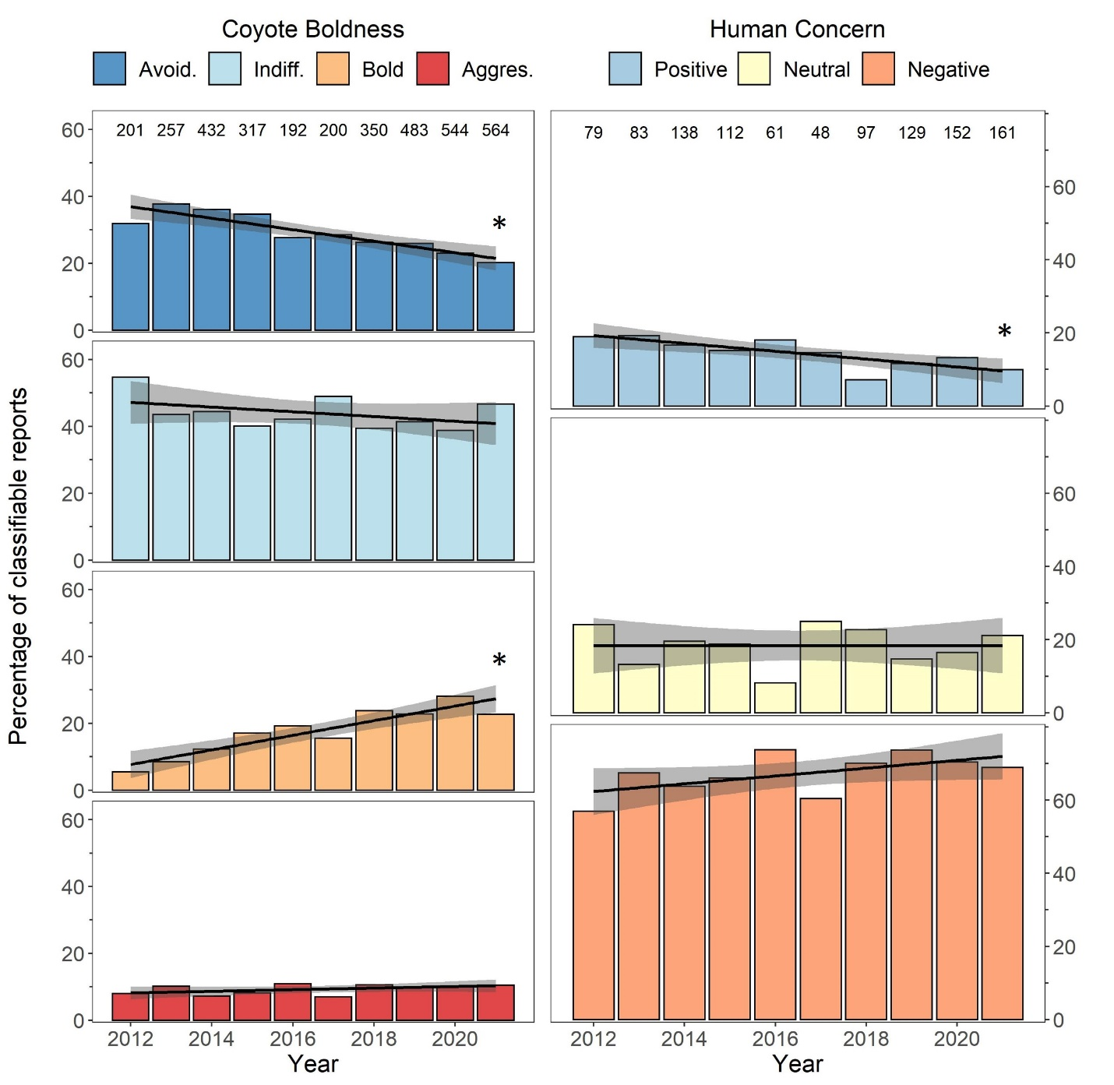

**Figure 6.** Long-term (10 year) trends in coyote boldness and human concern of coyotes as indicated by the percentage of reports in each of the boldness or concern categories. Reports were collected through the Edmonton Urban Coyote project website, and boldness and human concern were scored on ordinal scales using predetermined criteria. Numbers at the top of each chart denote the total number of reports for each year for which an ordinal score could be assigned. Linear trends are shown with 95% confidence intervals shaded in grey and significant trends are indicated by asterisks (p < 0.05).

**Figure 7:** Relationship between each of coyote boldness and human concern of coyotes with contextual independent variables (human activity, the presence or mention of vulnerable individuals, dog leash status, coyote number and coyote health). Colors represent Pearson’s residual values calculated post-hoc from statistically significant chi-square tests of independence, with positive values (red) indicating positive relationships and negative values (blue) indicating negative relationships. P values were adjusted for multiple comparisons with Holm’s correction and significance is indicated by asterisks (* p < 0.05, ** p <0.01, *** p < 0.001). Grey boxes (NA) indicate comparisons for which insufficient reports were available to allow for robust chi square tests (< 5 expected reports).